

**UNIVERSITY OF PETROLEUM & ENERGY STUDIES**

**Dehradun**

# Docker

**Experiment**

**Name: Harshil Bhardwaj**

**Course: B. TECH CSE DevOps (2018-22)**

**Roll no.: R171218045**

**Sapid: 500068580**

**Experiment- 10**

**Metadata and Labels**

Add a single label

$ docker run -l user=12345 -d redis



To create two labels in the file, one for the user and the second assigning a role.

$ echo 'user=123461' >> labels && echo 'role=cache' >> labels

The --label-file=<filename> option will create a label for each line in the file.

$ docker run --label-file=labels -d redis



By providing the running container's friendly name or hash id, you can query all of it's metadata.

$ docker inspect rd

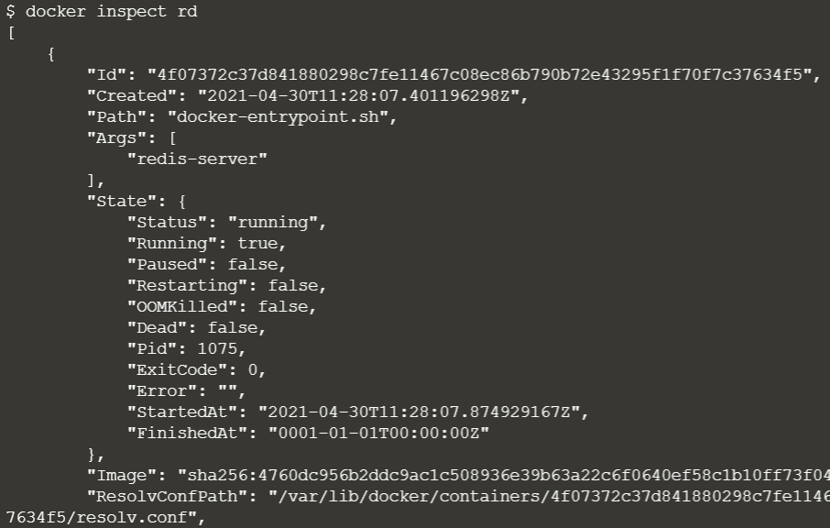

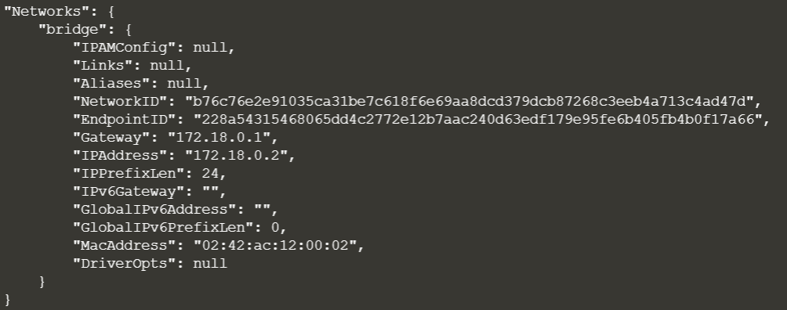

Using the -f option you can filter the JSON response to just the Labels section we're interested in.

$ docker inspect -f "{{json .Config.Labels }}" rd



Inspecting images works in the same way however the JSON format is slightly different, naming it ContainerConfig instead of Config.

$ docker inspect -f "{{json .ContainerConfig.Labels }}" katacoda-label-example



To show running label

$ docker ps --filter "label=user=scrapbook"



Filtering images

$ docker images --filter "label=vendor=Katacoda"

